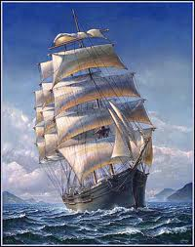
All aboard!
No.32, Summer 2022-2023
All us Catholics on board together
A quarterly Newsletter of encouragement for all Catholics in the parish of Saint Pius X, Heidelberg West.
Another reminder: With the fear of boring readers, here is yet another reminder of the whole idea behind the parish Newsletter, All Aboard. It is hand delivered to ALL members of the parish. It is to say: “You’re included! You’re part of the family. And do persist with your leading a good life with patience, generosity, honesty and joy. One of the greatest hopes in preparing and distributing All Aboard is that it might be encouraging! Hope you find it so.

Would you say that if your mother was listening?
We sometimes have the thought that we shouldn’t say anything that we wouldn’t want (or shouldn’t want) our mother to hear.
But another thought is that we shouldn’t say (or do) anything we wouldn’t like GOD to hear or see.
Some saints actually put up signs saying “GOD SEES ME” to remind them of just that fact.
When just about to say something nasty, or untrue, we might come up with an “Oops! Better not say that!” And besides having the thought that God sees me to stop me, I will also be saved from the upshot of saying something nasty; and that is that once said, it is impossible to take it back!
……………………………………………………………………………………………...
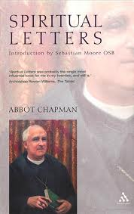
“I’m not much of a pray-er!”
A lot of us might honestly say that we are not good at praying. But we actually MIGHT be, but think we’re not.
A wise old abbot, John Chapman (1865-1933), had this advice:
“Pray as you can, and do not try to pray as you can’t.”
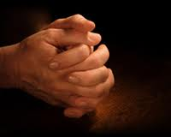
He gave this advice to the laypeople, monks, nuns, and priests who wrote to him seeking guidance in a life of prayer. Chapman was an English Benedictine monk, abbot, and scholar of early church history. But he’s best known for his Spiritual Letters, the collection of his replies to the queries of the men and women who wrote to him. [From the net]
If you can pray set prayers like the Hail Mary and Our Father, then do so.
If you pray little remarks to God such as “Thanks for the beaut day!” or “Please look after our young baby!” or “Please make this operation go right!” … then that’s the best way to pray.
If you like to take a little quote from the Gospels, such as the story of the Good Samaritan and then to think of the scene and say a prayer about it … then pray that way.
But the best advice is to KEEP PRAYING in the way that you can manage. And try to do so each day. A good practice is a Morning prayer and an Evening prayer (or more, of course).
+++++++++++++++++++++++++++++++++++++++++++++++++++++++++++++++++++++++++++++++++++++++++++++++
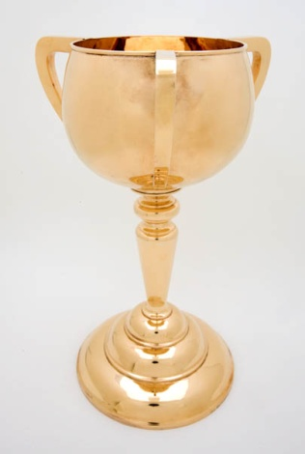
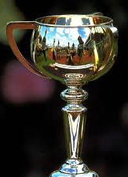
Why three handles on the Melbourne Cup?
I know it’s hard to believe that there are even some Melbournites who do not know that there are three handles on the Melbourne Cup. It began in 1919 when they put three handles on it. The idea is that one is for the owner, one for the trainer and one for the jockey. It’s a good example to us all to give credit where it’s due. Sometimes someone working in the wings or in the background deserves recognition. Let US be amongst those who DO recognise everyone’s contribution.
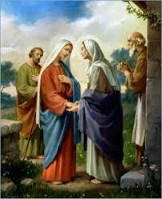
The Visitation (and an invitation)
When Mary learnt that both she and her cousin Elizabeth were both expecting a child Mary felt for Elizabeth who was much older than Mary and set out to visit her to share their excitement and to make certain that Elizabeth was well. In our time we can learn from Mary by visiting others to show that we care and love and that we are aware of the needs of others. We already witness this caring in our area through Vinnies visitations, through Exodus and through our local clergy visiting people in need in their homes.
Like Mary we can reach out to others and be willing to serve everyone, and not just those whom we like. If we are truly humble, our spirit of service would not make any discrimination among people and we would be willing to visit those in our parish who are in need. We can consider visiting the bereaved, the sick, the lonely, the disappointed and those who are no longer able to come to Mass or meet with family or friends.By visiting others we can bring them in close touch with Jesus not necessarily in spoken prayer but through our actions and our own silent contact with Him.
At St Pius X we are forming a visitation group. You are more than welcome to join this group and/or to request a visit for yourself or others whom you know are in need.

To show your interest in this group please contact the Parish Office on 9457 5794

++++++++++++++++++++++++++++++++++++++++++++++++++++++++++++
WHEN I HAVE TO ENDURE!! Same old … same old … same old …
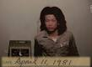
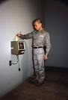
Tehching Hsieh may be an inspiration! (Maybe not!) For one year, this “performance artist” punched a worker’s time clock located in his studio, on the hour, every hour, … for ONE YEAR! This was an “artistic performance”. So, the most sleep he could ever get was about 55 minutes between each punch-time/ photo. While he began with a shaven head, the accompanying photo shows his hair growth by the end.
Now, dear reader, what can we learn from this? And is there any reflection I might make about my life and how I cope with things that happen?
And don’t forget that this fellow chose to do this, and persevered with it till the end of 365 days!
Each of us will have our own reflections, of course. And it might be interesting to compare with someone else!
Patience
Your/my WONDERS OF THE WORLD
What do you find to be the most amazing wonder of the world? It does not have to be a monument … it can be anything!
When some prominent people were invited to contribute to a TV program, they were asked to nominate their SEVEN WONDERS OF THE WORLD. A British scientist, James Lovelock, included “Standing Up”! … and when you think of it, there is a lot going on in “standing up”! The knees are not SET in a position to not collapse. And what stops us from falling over? And how do children learn to “stand up”?

So that’s one of James Lovelock’s WONDERS. But what’s yours/mine? In the spiritual sphere it might be forgiveness; the forgiveness by those who have suffered a terrible injury or injustice. But in the physical world – the world of biology – surely metamorphosis is an almost unbelievable wonder. How a grub goes into a cocoon … becomes a messy blob … and finishes up a moth or butterfly is cause for WONDER.

Now, over to you, dear reader. What is YOUR Wonder (or Wonders) of the World?
By Connie Campbell Bratcher
Oh, how we need patience
In our busy world today;
We have so many things to do
There's hardly time to pray.
Our calendars are so filled
That when we need to help a friend,
We find our patience running short-
Our schedules just won't bend.
Father, help us to be flexible,
And always follow Your lead,
As we help our friends
In their time of need.
We pray we'd have tender hearts
That truly understand,
Willing to go the extra mile
For our fellowman.
May our priorities always be
What You'd have them to be-
The needs of others first-
The things of eternity.
Give us empathy, and patience
That comes only from You,
And help us to be Christ-like
In everything we do.
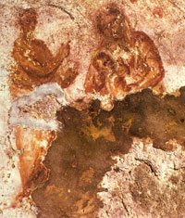
Earliest picture of Mary with Jesus (maybe!)
The earliest surviving Christian art is preserved on the walls of tombs belonging to wealthy Christians in the catacombs of Rome. From literary evidence there may also have been panel icons. However, like almost all paintings from classical times, these have disappeared. The earliest known image of the Virgin Mary independent of the Magi episode is a fresco dated about 150 CE in the Catacomb of Priscilla on the Via Salaria in Rome that shows her nursing the infant Jesus on her lap.

[This picture and text is found on the net at http://www.historyofinformation.com/expanded.php?id=3073 and is part of Jeremy Norman’s HistoryofInformation.com]
++++++++++++++++++++++++++++++++++++++++++++++++++++++++++++++++++++++++++++++++++++
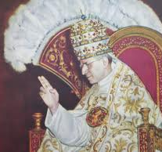
The way we were
It’s almost unbelievable that the Pope (as recently as the 1960s) occasionally wore an enormous TIARA crown of gold and precious gems! And in the photo, notice also the great feather fan! It was thought for centuries that all this grandeur was fitting for someone who was the successor of JESUS! Everything had to be special and precious and grand!
But some would say that over the years a political and secular intention had crept into this display of grandeur.
The explanation of the enormous three-tiered crown is not perfectly clear, which is another matter of amazement. Part of the Wikipedia explanation of the symbolism is as follows:
There is no certainty about what the three crowns of the Triple Tiara symbolise, as is evident from the multitude of interpretations that have been and still are proposed. Some link it to the threefold authority of the "Supreme Pontiff: Universal Pastor (top), Universal Ecclesiastical Jurisdiction (middle) and Temporal Power (bottom)". Others interpret the three tiers as meaning "father of princes and kings, ruler of the world, vicar of Christ". The words that were used when popes were crowned were: Accipe tiaram tribus coronis ornatam, et scias te esse patrem principum et regum, rectorem orbis in terra vicarium Salvatoris nostri Jesu Christi, cui est honor et gloria in saecula saeculorum ("Receive the tiara adorned with three crowns and know that thou art father of princes and kings, ruler of the world, vicar on earth of our Saviour Jesus Christ, to whom is honour and glory for ever and ever").
Very refreshing, therefore, that Pope Francis has nothing to do with any fancy decoration, but is much closer to what we believe Jesus would have been like!
**************************************************************************************************************************************
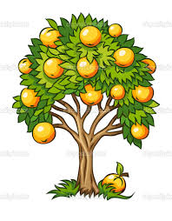
Who planted that tree?
The Vietnamese have an interesting take on appreciation. “When eating a fruit,” and old saying goes, “think of the man [or woman] who planted the tree.”
Imagine if we did that with everything! We might think of the people who grow our food; resurface our roads on which we travel to work; work the powerplants that keep our homes warm; pick the tea we drink … the list is endless.
We would soon find we have lots of things to be thankful for – not such a bad thing, surely, when putting life into perspective.

[Taken from The Friendship Book, 2011, by Francis Gay]

**********************************************************************************************************************************
What you say
Do-it-yourself prayer
When you drive past a Primary School or see young children in the Mall, what do you wish for them?

Never thought about it? Do so now. Pray for them!
Say to someone something kind
Speak praise sincerely meant,
Express appreciation
And give encouragement.
For we inspire and influence,
Just through the words we say,
Within us lies the power to bless
And change somebody’s day.
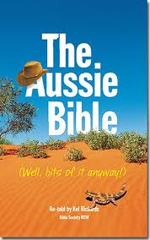
Reminder: The “translation” of the Bible in this book is the work of Australian journalist, Kel Richards. See what you think about the way he tells the story in old-style Aussie slang and expression:

HOMETOWN BLUES (Luke 4, 16-30)
He went back to his hometown of Nazareth, and on Saturday he went to the Jewish Meeting Hall, and stood up to read the Bible. The bit he read came from Isaiah, and he read these words: “God’s Spirit is on me. He’s picked me to tell good news to the poor, set the prisoners free, open the eyes of the blind, give a hand to the downtrodden, and tell everyone this is the time God has chosen.” Then he closed the Bible, gave it back to the usher and sat down. Everyone’s eyes were glued on him as he said, “This bit of the Bible has come true today, right here and now.”
The whole mob liked him, and spoke well of him and said how well he spoke. “How come?” they all said, “this is just the carpenter’s kid.”
Jesus said to them: “I reckon I know what you’re going to say, you’ll quote the old proverb, ‘Doctor, treat your own illness’ – meaning, ‘Do the stuff here in your hometown that you did in Capernaum.”
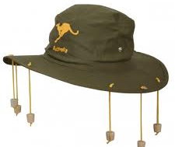
But straight up, no one who speaks God’s words is listened to in his hometown. Back in Elijah’s day there was a drought for three and a half years and everyone was scratching for food. There were heaps of widows in Israel – but God didn’t send Elijah to any of them, but to a foreign widow (in Deraphath, on the Sidon road). And in Elisha’s day there were heaps of lepers in Israel, but the one God healed was a foreigner – Naaman, the Syrian.”
At this the whole mob blew a fuse, and decided to throw him out of town. Worse, they dragged him to a cliff and were about to chuck him down, when they found he’d slipped through their fingers, and left them.”
+++++++++++++++++++++++++++++++++++++++++++++++++++++++++++++++++++++++++++++++++++++++++
Time for a New Year Resolution! … but it’s not New Year!!!

OK! It’s not New Year in the traditional sense … but every day is the start of a “new year”. And if a resolution is worth making, TODAY is the best time to start! It may be to give a greeting when you see someone for the first time in the day; it might be to tidy up rather than leaving tidying up my mess to someone else; it might be to not have “seconds” at meal times; it may be to say an Evening Prayer of thanks for all the good things that happened during the day (even if there were unpleasant things as well!)
Unless we’re already perfect, of course, and then there’s no need for resolutions.
………………………………………………………………………..
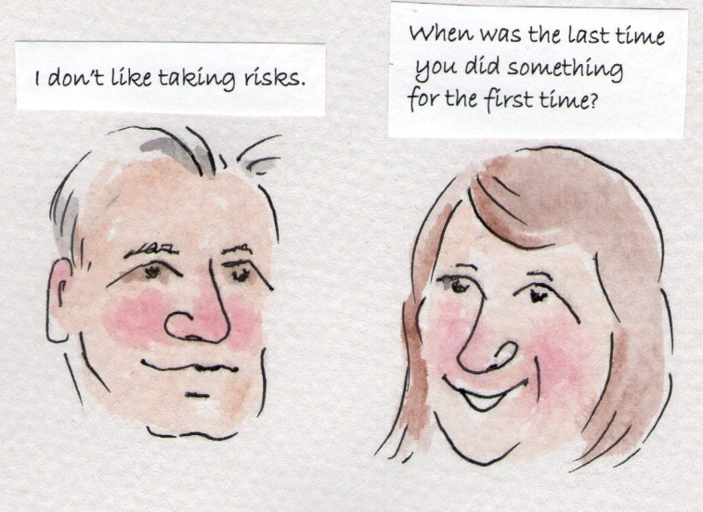
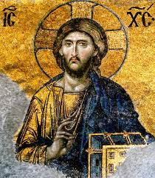
Story of this mosaic icon.
Occasionally in All Aboard this image is used to accompany an extract from the Gospels.
It is found in the ancient Hagia Sophia church/mosque/museum in Instanbul and is a large mosaic.
The original church was built by in 537 by the Emperor Justinian --- and it is still standing and people will be visiting it as you, dear reader, are reading this!
When it was converted into a mosque the many mosaics like this one were covered up with plaster. But the image was still behind the plaster and is now revealed for all to see.
Contacts: St Pius X Catholic Parish Heidelberg West
Father Wayne Edwards: St Pius X Presbytery 419 Waterdale Rd., Heidelberg West 3081
Tel: 9457 5794; Email: stpiusvic@bigpond.com
Exodus Community: 273 Liberty Parade, Heidelberg West, Tel: 9457 7593
School Principal: Barbara Gomez, Tel: 9457 3776 principal@spheidelbergwest.catholic.edu.au
Mass times: Saturday evening Vigil – 7.00pm; Sunday: 9.00am & 11.00am (12.00 noon, Exodus Community – all welcome – 273 Liberty Parade (behind house)
Weekdays: 9.00am Tuesday, Wednesday, Thursday, Friday and Saturday
Confessions and Rosary: After 9.00am Mass Saturday mornings
Church open for prayer: 8.30am – 4.00pm on school days only
Taize Prayer: Last Friday of the Month, 6.00-7.00pm
All Aboard editor/compiler: Brother Barry Lamb at barrylamb@hotmail.com or 9456 9641

